**The Brouwer Fixed Point Theorem：**

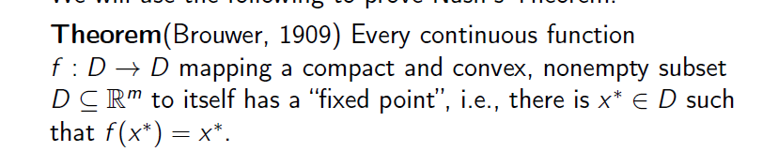

**Nash theorem:**

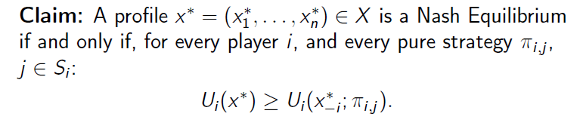

Proof:

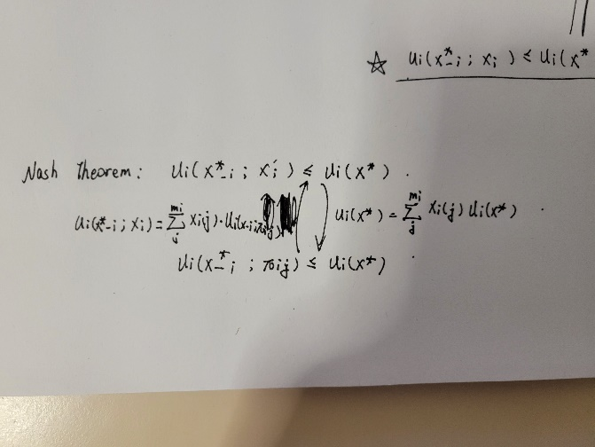

**Pareto optimal (Pareto efficient):**

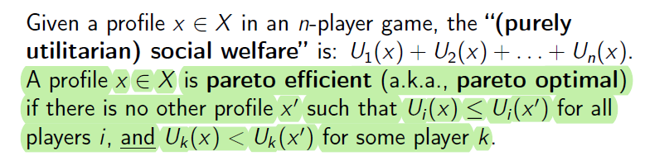

**Evolutionarily Stable Strategy (ESS):**

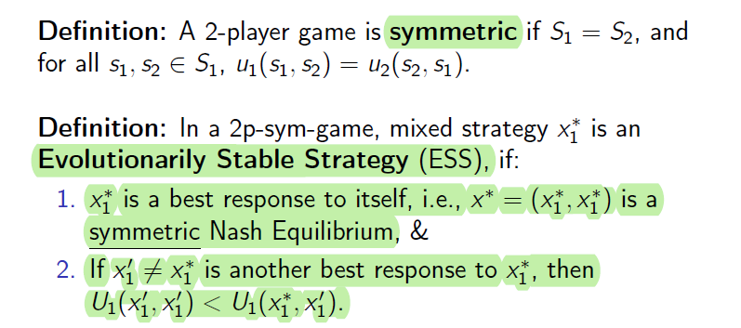

Also, every symmetric game has a symmetric NE.

**RKN hypothesis:** every player’s ‘rationality’ is common knowledge among all players.

**Perfect Information:** 1 node per information set.

**Memoryless strategy:**

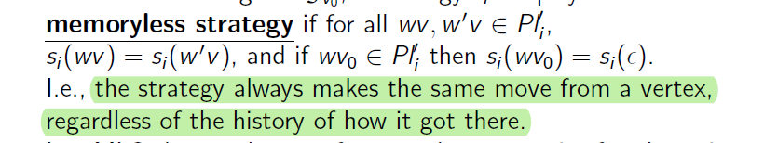

**Find the memoryless winning strategy for player 1.**

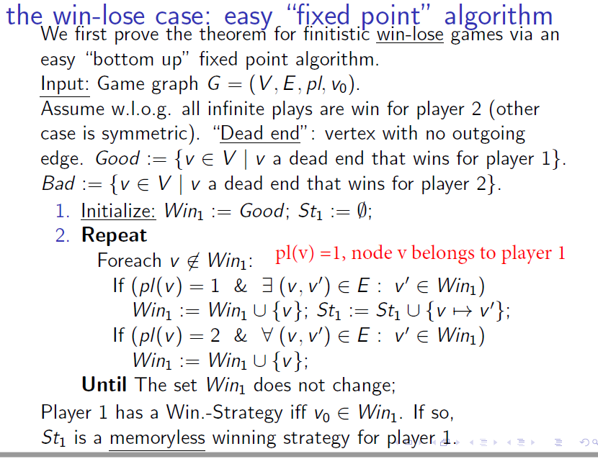

**Finitistic games on finite graphs are memorylessly determined. Moreover, there is an efficient (P-time) algorithm to compute memoryless value-achieving strategies in such games.**

**Bellman Optimality Equations:** maximizing the probability to reach target vertex.

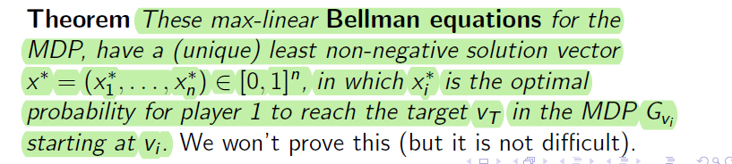

**Congestion Game:** 